Let’s go shopping today!
Brookies bakery

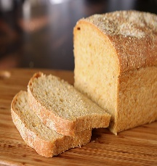
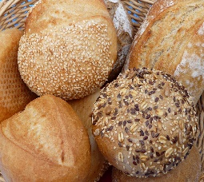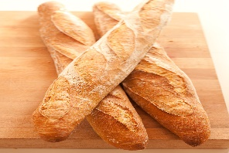
rolls loaf baguette croissant
4p 10p 7p 6p
How much altogether?

1 loaf and 1 croissant =
3 croissants =
1 roll and 1 baguette =
1 roll and 1 croissant =
CHALLENGE!!!!
1 loaf, 1 baguette and 1 croissant =
1 loaf, a roll and a baguette =
2 baguettes and 1 roll =
1 roll, 1 loaf, 1 baguette and 1 croissant =

