Stamps

1p
2p
5p

Samantha Near
7 Round the Corner
Closeby

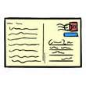
You have ten postcards to post.
Each letter needs 10p worth of stamps.
Make 10p in different ways.

Going Further

Letters cost 12p. Make up the total in different ways.

