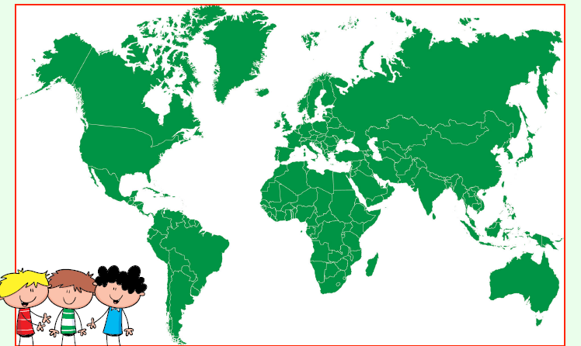
P3 this is a map of the world.
Can you find Spain? Can you see how close Spain is to Italy and France ?

