Food around the world quiz
- Read the clues
- Which food is it?

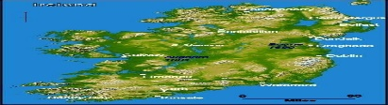

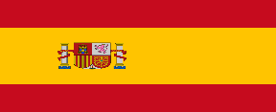
- What country is it from?

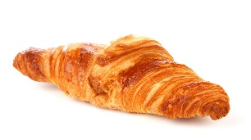
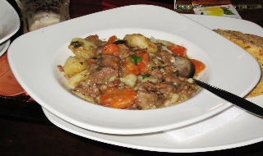
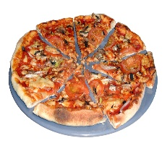
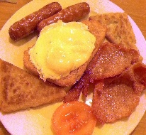
The pictures will help you work out the answers.
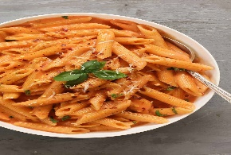
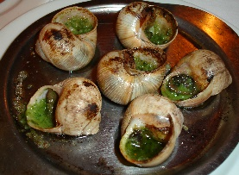
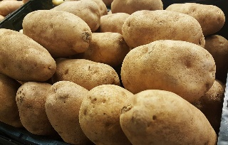
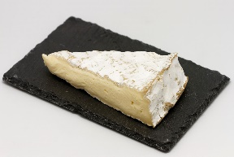
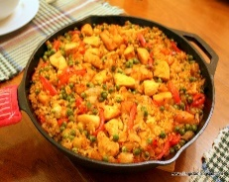
Clue | Food | Country
A lovely weekend breakfast.
Chips are made from this type of food.
This food is an animal in a shell.
Mrs Connery loves this on crackers.
Miss McWilliams’ favourite topping on this food is pepperoni.
Spaghetti is made from this.
A lovely dinner on a cold Winter day.
There are a lot of different types of fish in this dish.
This is delicious heated up with jam.

