3D Shape Hunt
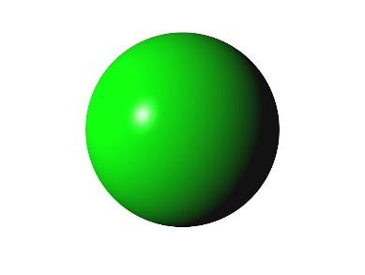
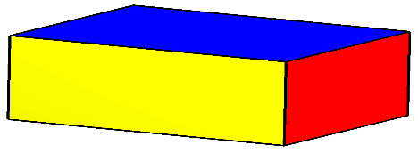
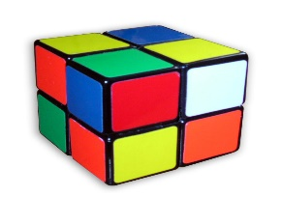

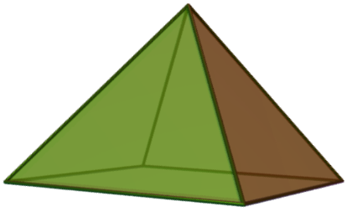
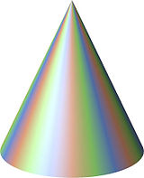
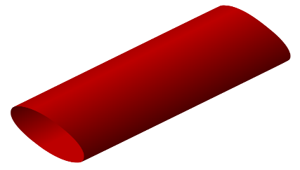

Which is which?
cone sphere cuboid
cylinder pyramid cube

Name all of these shapes and then have a 3D shape hunt.
How many things can you find around the house that are these shapes?

When you’ve gathered them all together take a picture and send it to us please. We love seeing your photos.

