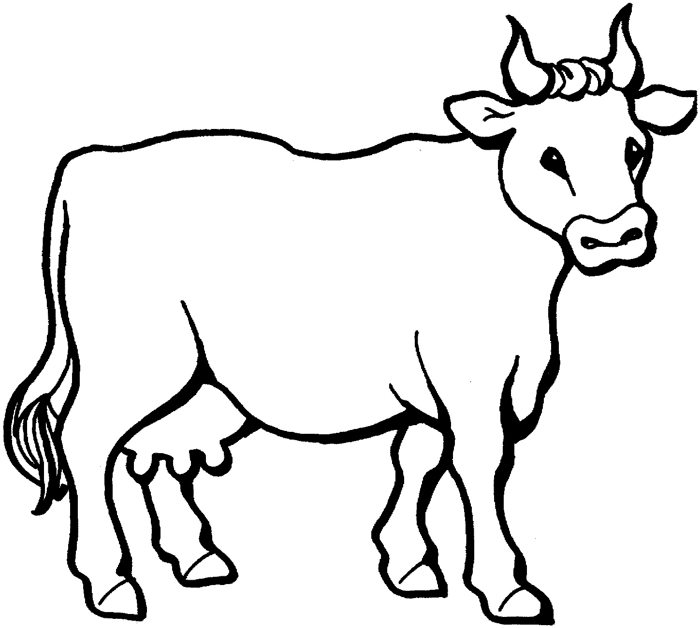
Milk comes from cows. Draw the dairy foods that are made from milk inside the cow.
Made from milk

