
On the Farm
Farmer Joe is having a few problems on his
farm today. Can you help him solve them?

  Farmer Joe had 16 pigs on his farm. His friend sold his farm and gave Farmer Joe 21 more. How many pigs does he now have altogether? | 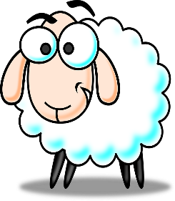  Farmer Joe was herding up his 35 sheep.13 of them escaped. How many of Farmer Joe’s sheep were left?
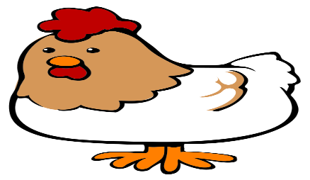  Farmer Joe had 2 hens on his farm. One morning 1 of the chickens laid 23 eggs and the other one laid 24 eggs. How many eggs were there altogether? |   Farmer Joe had 43 cows. He didn’t have enough room in the field for them all so he had to sell 22 of them. How many cows did he have left?

