
On the Farm
Farmer Joe is having a few problems on his
farm today. Can you help him solve them?

  Farmer Joe had 6 pigs on his farm. His friend sold his farm and gave Farmer Joe 11 more. How many pigs does he now have altogether? | 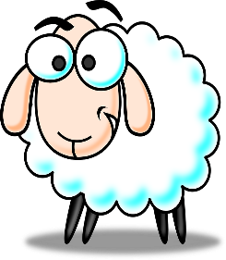  Farmer Joe was herding up his 19 sheep. 6 of them escaped. How many of Farmer Joe’s sheep were left?
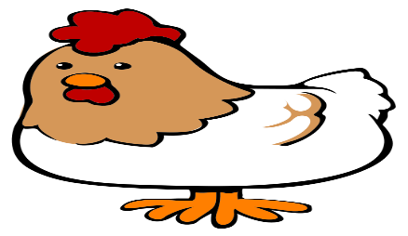  Farmer Joe had 2 hens on his farm. One morning 1 of the chickens laid 9 eggs and the other one laid 5 eggs. How many eggs were there altogether? |   Farmer Joe had 18 cows. He didn’t have enough room in the field for them all so he had to sell 5 of them. How many cows did he have left?

