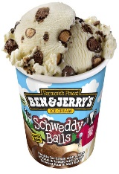
Brookies Dairy Shop
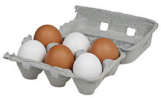
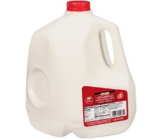
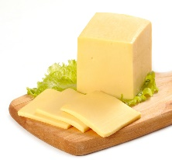
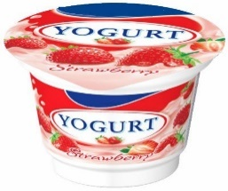
Price list
milk – 14p
cheese – 23p
yogurt – 15p
eggs – 21p
ice cream – 27p
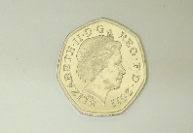
You are going shopping with 50p

How much change would you get if you bought. . .

milk and eggs –
yogurt and cheese –
ice cream and milk –
cheese and milk –
eggs and yogurt –
cheese and eggs -

