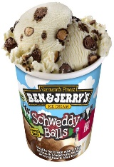
Brookies Dairy Shop
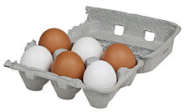
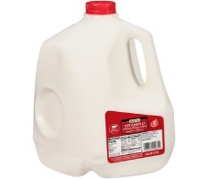
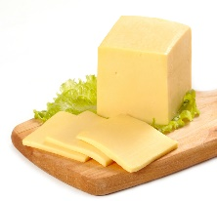
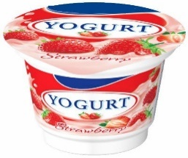
Price list
milk – 4p
cheese – 11p
yogurt – 5p
eggs – 8p
ice cream – 7p
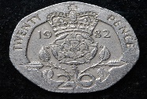
You are going shopping with 20p.

How much change would you get if you bought…

milk and eggs –
yogurt and cheese –
ice cream and milk –
cheese and milk –
eggs and yogurt –
cheese and eggs -

