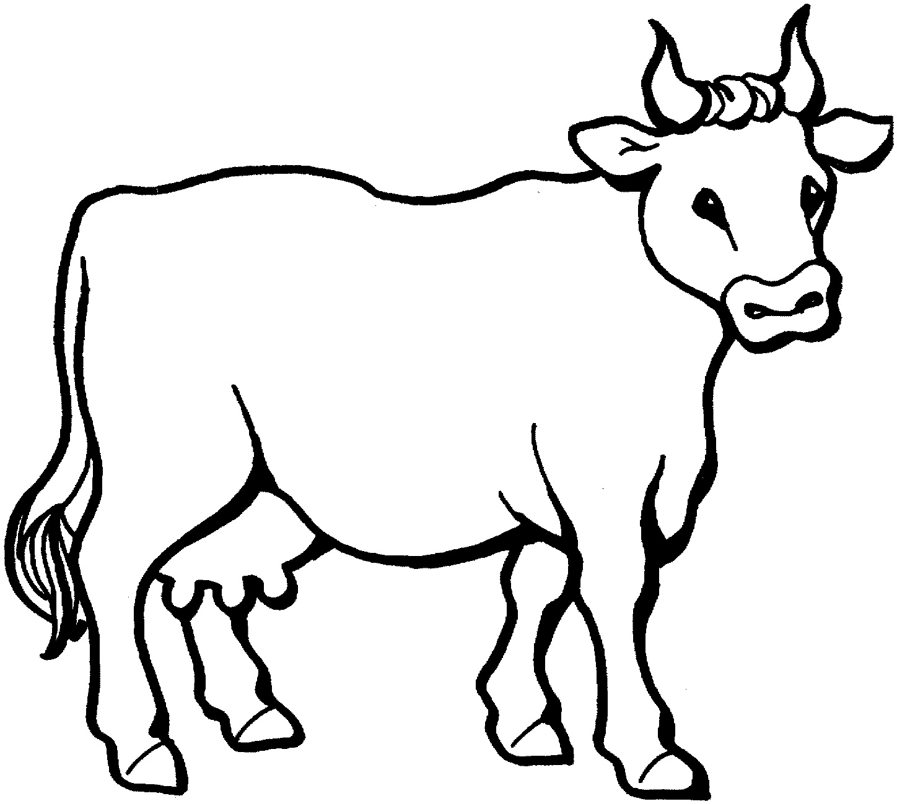
Cow Parade
Decorate or design your own cow for the Brookies Cow Parade !

