Friday 5th June WALT be creative.
Cow Art
Today we would like you to draw, paint or make a cow.
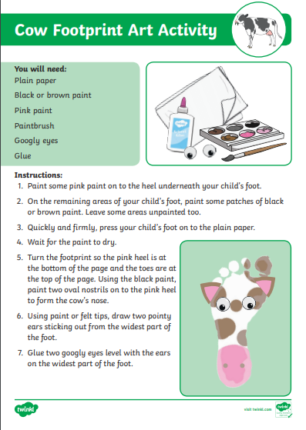
Below are some instructions for a footprint cow which you may like to try – ask a grown up first !

