This is a map of the world. Can you find Italy on the map?
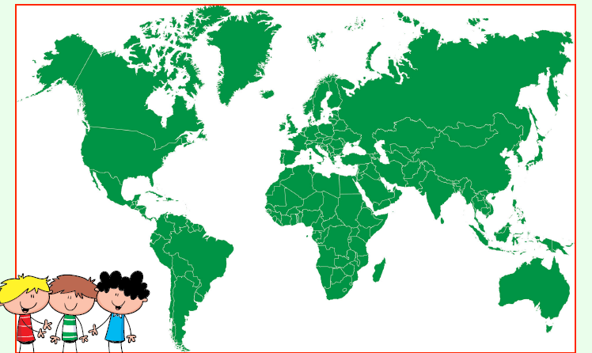
Hint – remember what shape Italy is P3!

