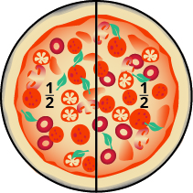
Pizza fractions
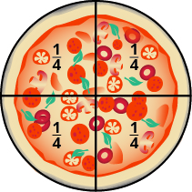
Draw 2 large circles on a page (try drawing round a plate). These will be your 2 pizzas. (you could draw the tomato sauce and cheese onto them now).

Using a ruler draw a line on the 1st one to divide it in half.
On one half add mushrooms.
On the other half add pepperoni.

Using a ruler draw 2 lines on the 2nd one to divide it into quarters.
On one quarter draw ham.
On two quarters draw pineapple.
On the last quarter draw pepperoni.

Miss McWilliams and Mrs Connery would love you to send them pictures of the pizzas, so that we can share them with all of your friends on our home learning page.

