P3 Pizza Kitchen
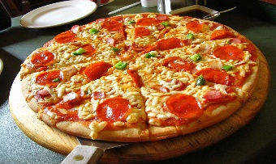
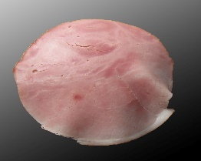
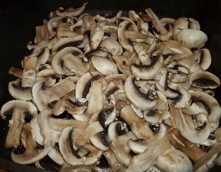
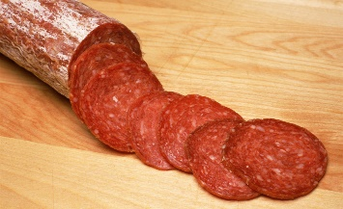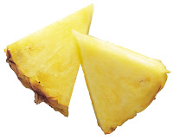
mushrooms 2p ham 4p pepperoni 5p pineapple 3p

Who’s hungry?
Let’s order some pizza!
A cheese and tomato pizza is 5p but you can add some delicious extra toppings from the menu above.
How much would these pizzas cost?

1 pizza with ham and pepperoni = (Miss McWilliams’ favourite)
1 pizza with mushrooms and pineapple =
1 pizza with ham and mushrooms = (Mrs Connery’s favourite)
1 pizza with ham, mushrooms and pineapple =
1 pizza with ham, pepperoni and mushrooms =
1 pizza with all 4 extra toppings =

