
Five Pin Bowling

What pins must fall down?

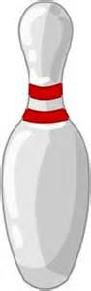
Find 2 different ways:
1
4
- to score 6
2
- to score 7
- to score 8
3
5



Going Further

Find different ways of scoring 10.
Finding All Possibilities
FS

