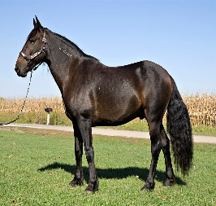
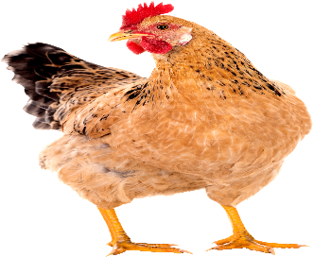
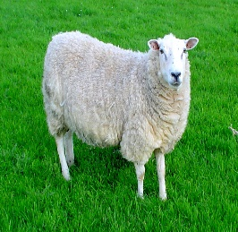
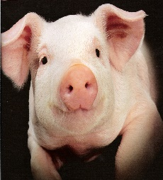
Brookies Animal Market
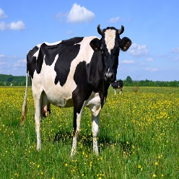
Price list
pigs – 23p
sheep – 17p
cows – 21p
horses – 19p
hens – 14p

How much would it cost to buy ………
A pig and a hen ________
2 horses _________
A cow and a sheep __________
A hen and a cow ___________
3 cows _____________
A cow, a horse and a hen ____________
2 pigs and a hen _____________
2 sheep and a horse ______________

