
On the Farm
Farmer Joe is having a few more problems on his
farm today. Can you help him solve them?

  Farmer Joe had 12 pigs on his farm. His friend sold his farm and gave Farmer Joe 10 more. How many pigs does he now have altogether? | 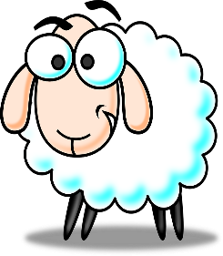  Farmer Joe was herding up his 15 sheep. 9 of them escaped. How many of Farmer Joe’s sheep were left?
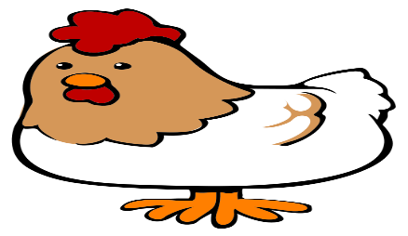  Farmer Joe had 2 hens on his farm. One morning 1 of the chickens laid 13 eggs and the other one laid 6 eggs. How many eggs were there altogether? |   Farmer Joe had 12 cows. He didn’t have enough room in the field for them all so he had to sell 8 of them. How many cows did he have left?

