Wednesday 17th June WALT write a description.
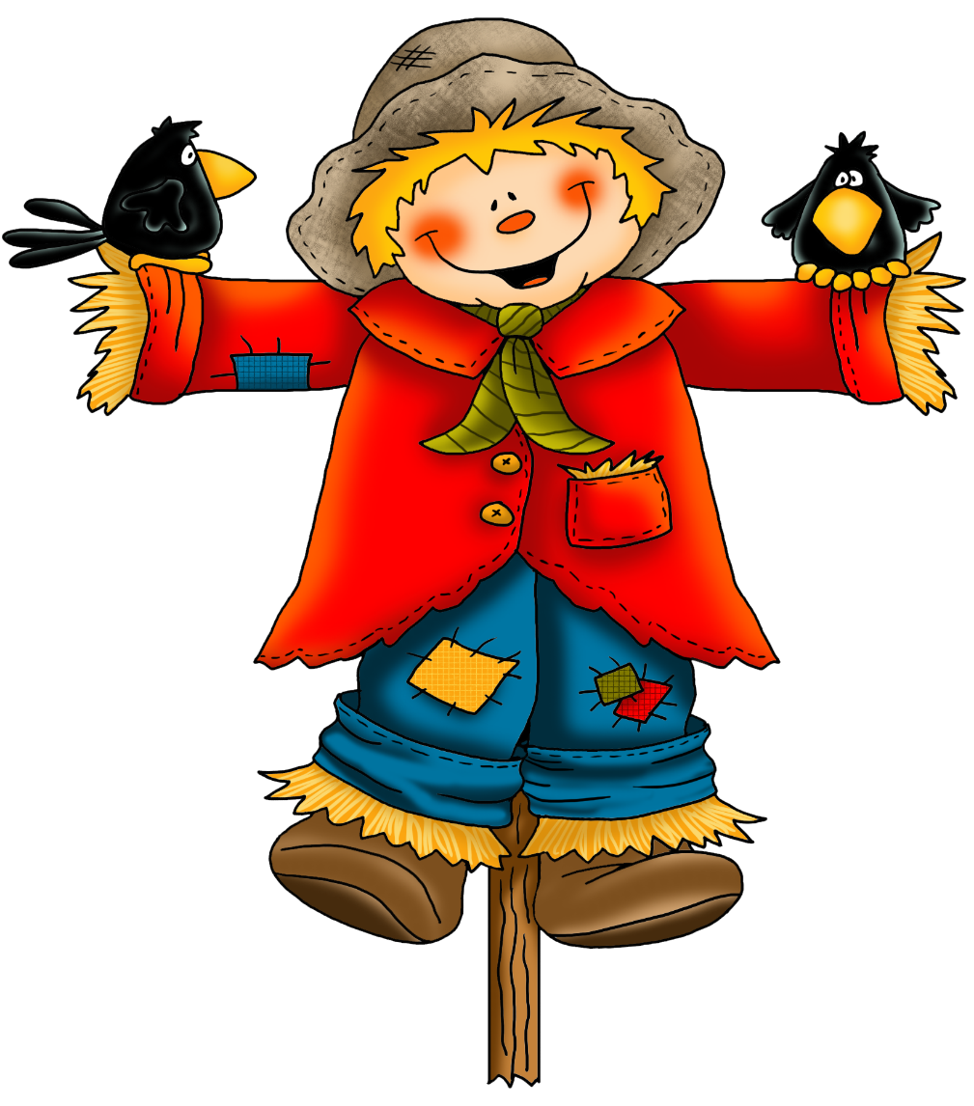
Look at the picture of the scarecrow. Write some sentences to describe him.

.

.

.

.

.

.

