Friday 12th June
Fruit shop owner Fred is having a few problems in his shop today. Can you help him solve them?

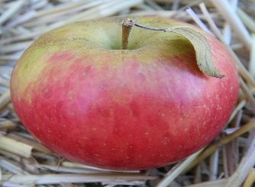  Fred sold 24 apples to Mrs. Connery. 8 of them were rotten. How many apples were good to eat? | 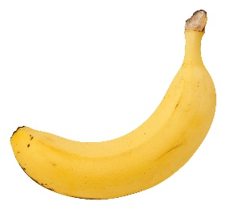  Miss McWilliams bought 17 bananas and Mrs Connery bought 18 bananas. How many did they have altogether?
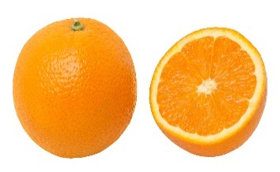  Mrs Connery bought 33 oranges and Miss McWilliams ate 11 of them. How many were left? | 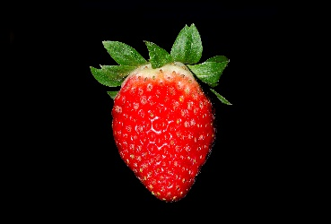  Miss McWilliams and Mrs Connery both bought a punnet of strawberries. Miss McWilliams had 22 and Mrs Connery had 19. How many strawberries were there altogether?

