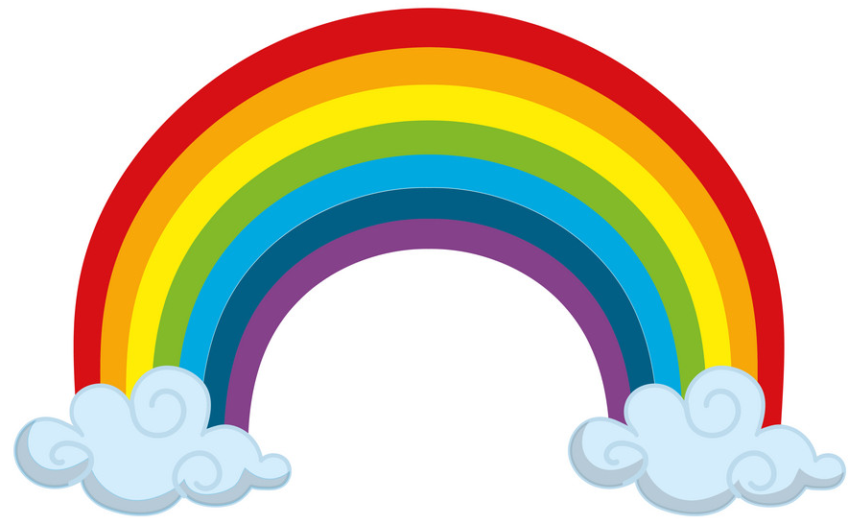
Tuesday 9th June WALT use similes.
as red as _____________________________________________.
as orange as ___________________________________________.
as yellow as ____________________________________________.
as green as ____________________________________________.
as blue as _____________________________________________.
as purple as ___________________________________________.
Can you create a similes rainbow?

