Wednesday 10th June We are learning new vocabulary.
Can you match the correct word with its meaning?

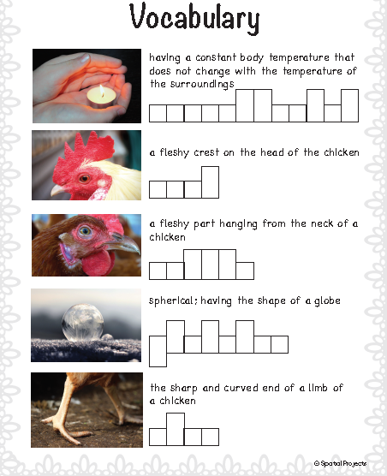

globular | wattle | chicken
warm-blooded | comb | claw

