Friday 12th June
Fruit shop owner Fred is having a few problems in his shop today. Can you help him solve them?

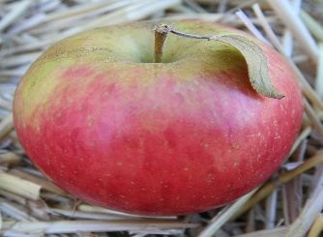  Fred sold 12 apples to Mrs. Connery. 8 of them were rotten. How many apples were good to eat? | 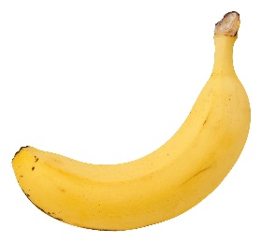  Miss McWilliams bought 11 bananas and Mrs Connery bought 9 bananas. How many did they have altogether?
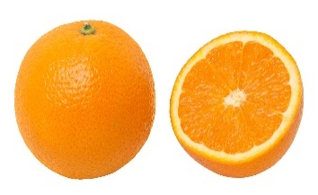  Mrs Connery bought 13 oranges and Miss McWilliams ate 6 of them. How many were left? | 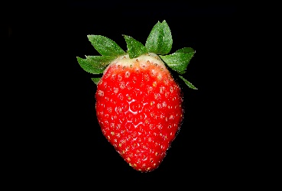  Miss McWilliams and Mrs Connery both bought a punnet of strawberries. Miss McWilliams had 9 and Mrs Connery had 8. How many strawberries were there altogether?

