Animals of the Antarctic LC
Oh no, a big gust of wind from the South Pole blew all Miss McWilliams’ notes everywhere! Now they are all mixed up!
Can you match the descriptions to the correct animal?
Animal name | Description
Emperor Penguin  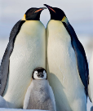 | The largest of all the  penguins.
Krill  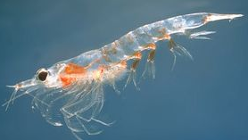 | A tiny shrimp like  creature.
Skua  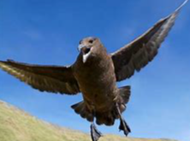 | A bird that is a fierce  hunter.
Leopard Seal  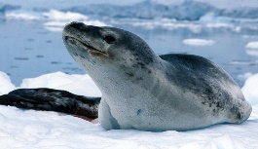 | A seal with black spots on  its back.
Use your knowledge of Antarctic Animals to help you.

