WALT write a list.
Antarctic Exploration
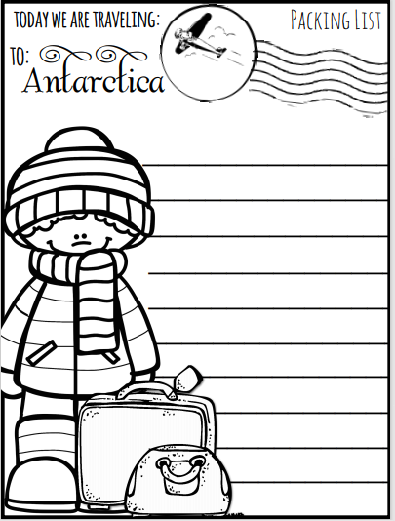
Can you write a list of the items you would need to pack if you were going to explore Antarctica? Think carefully about the weather you might expect to find!!

