Wednesday 3rd February
Brookies Sweet Shop
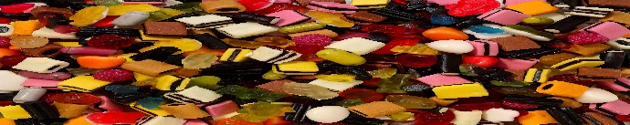
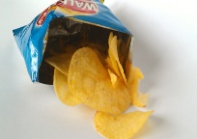
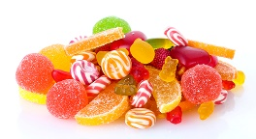
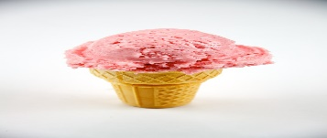
Price list
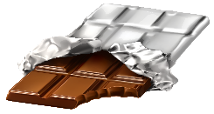

sweets crisps chocolate ice - cream
18p 13p 17p 14p
buy | total cost | coins
sweets and
ice - cream
crisps and
chocolate
sweets and
chocolate
crisps and
ice - cream
crisps, chocolate and ice - cream

