Wednesday 3rd February
Brookies Sweet Shop
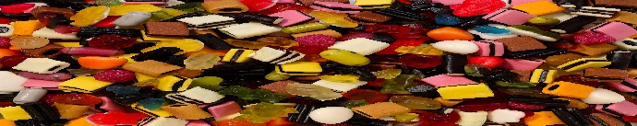
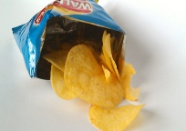
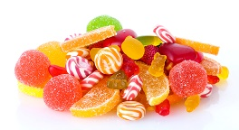
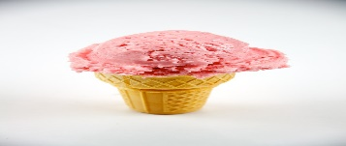
Price list
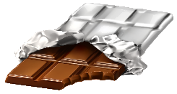

sweets crisps chocolate ice - cream
12p 11p 14p 10p
buy | total cost | coins
sweets and
ice - cream
crisps and
chocolate
sweets and
chocolate
crisps and
ice - cream
crisps, chocolate and ice - cream

