Look at the photos below and imagine you are in Antarctica.
How would you describe what you can see to your family at home?
All you need to complete the task is a pencil and a page.

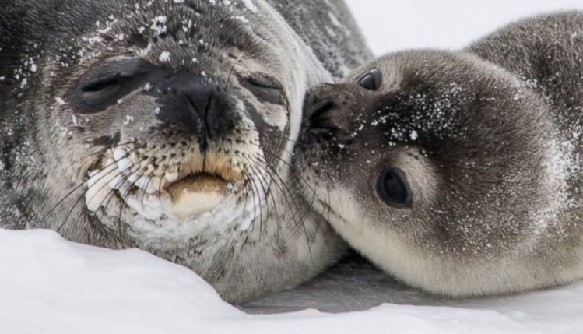

1

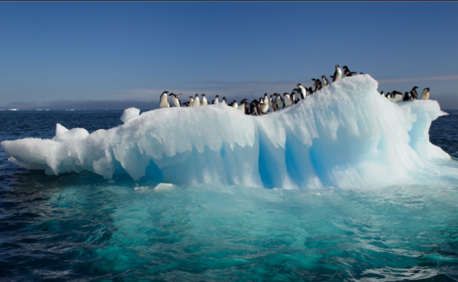

2

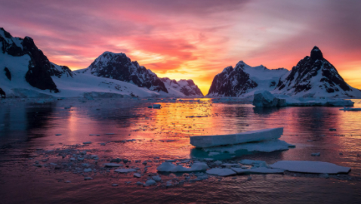

3

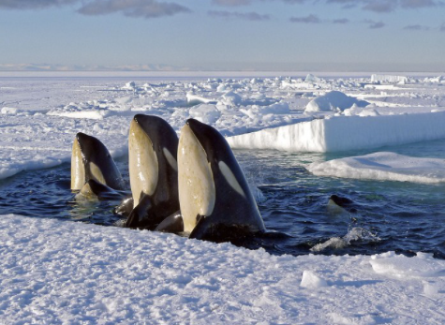

4

