Social Story

Helping us to Understand Coronavirus
Covid-19

- Coronavirus can be called ‘Covid-19’
- Coronavirus is a new type of flu.
- A flu can make you feel unwell, but it is ok, you will feel better again.

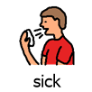

- I can keep safe from Coronavirus by washing my hands with soap and water.
- I will wash my hands before I eat my food.
- I will wash my hands after I sneeze, blow my nose, cough or touch my mouth.
- I will wash my hands after I go to the toilet.
- Having clean hands helps me to stay safe.
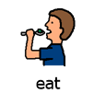
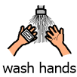
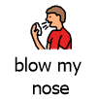
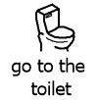

- I will not bite my nails or put my hands in my mouth.
- I will cover my mouth when I cough or sneeze.
- If I am not feeling well, I will tell a grown-up.
- I will not give my friends or staff high 5’s, a hug or fist bumps until everyone is feeling better.
- I can do other things to be friendly, like give them a wave or an elbow bump.
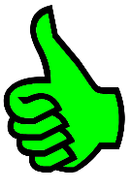
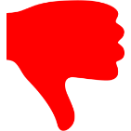
Unhealthy choices hea Healthy choices
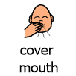
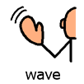
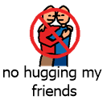
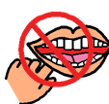
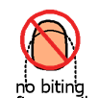

- My school is closing for a while – most children will stay at home instead.
- I will do my reading and activities my teacher has given me.
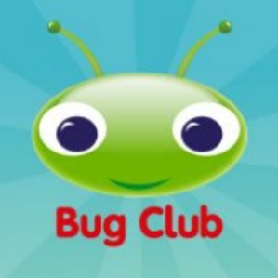
- I will do my tasks on Bug Club, Education City and check my year group page on the Brooklands Website for activities.
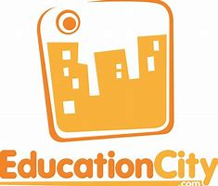
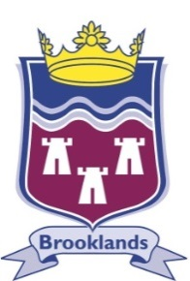

- School will be closed to let everyone get better.
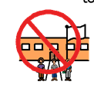
- My family will let me know when I can go back to school.

- Just like any other types of flu, coronavirus will go away.
- I don’t need to feel worried, but if I do, I can talk to an adult.
- I will keep safe


