LEOPARD SEAL FOOD

Today you are going to use your imagination to create a menu for a Leopard Seal café !!

What will your café be called?
What will the seals eat?
How much will the food cost?

Look at the example below to give you some ideas on how to present your menu and think about the facts from the Power Point.

Include some pictures on your menu, for example, seals or snowflakes.

We can’t wait to see what ideas you come up with P3!

All you need to complete this task is a pencil and a page, have fun !!


fish krill penguin
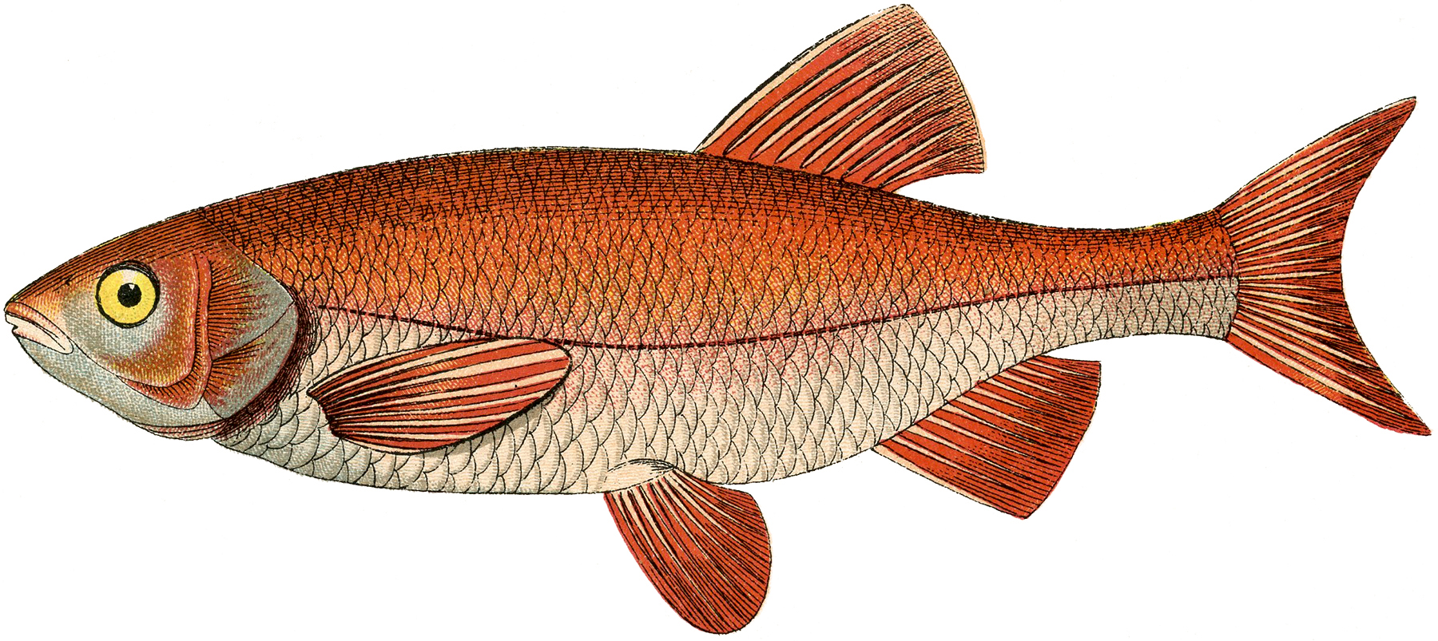
Welcome to the South Pole Seal Café
Can you complete the menu below by filling in the missing letters? Use the words in the box below to help you.

MENU
F_ __ Stew 14p
F_ __ Finger Sandwiches 24p
Spicy Kr_ __ Soup 17p
Kr_ __ and f_ __ pie 15p
P_ _ g _ _ _ biscuits 19p



