Tuesday 23rd February
Read the sentence and draw the correct number of each object.

three cars  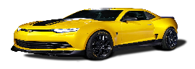 | one apple  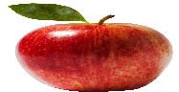
five dogs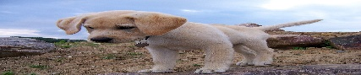 | two cats  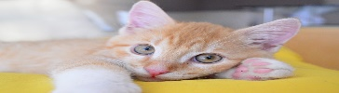
four bananas  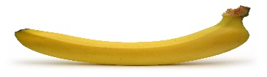 | six cakes  

