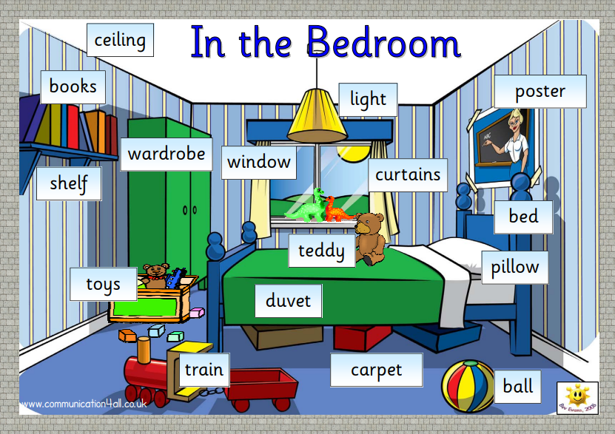

Paint £7 a tin
Toy train
£6
Ball £3
Pictures £3 each
Teddy Bear £4.50
Toys from £5

Books £2 each

