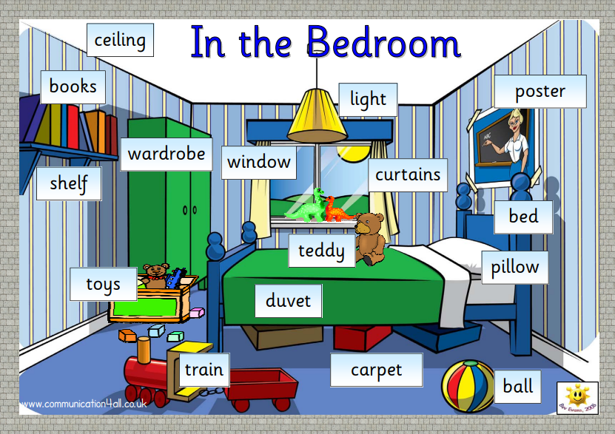

c £25
d £5
c £5
s £3
b £8
w £20
Paint £7 a tin
Toy train
£6
Ball £3
Pictures £3 each
Teddy Bear £4.50
Toys from £5
Books £2 each
l £10
p £1

