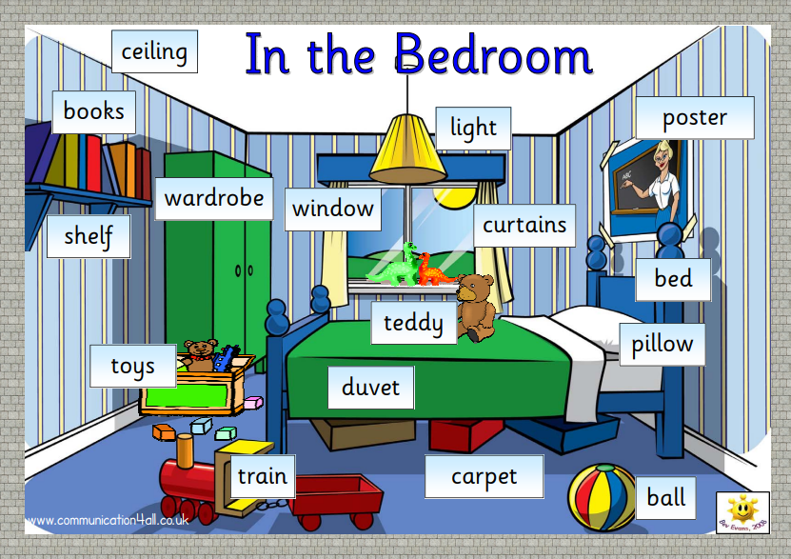

c_ _ _ _ _ _ _
w_ _ _ _ _ _ _
teddy Bear
d _ _ _ _ _
c _ _ _ _ _ _
s_ _ _ _ _ _
b _ _
paint
toy train

ball
pictures
toys
books
l _ _ _ _
p _ _ _ _ _

