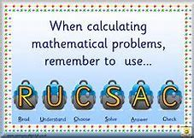
Houses and Homes Word Problems
WALT: read and understand word problems.
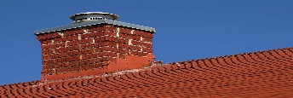  There was smoke coming out of 12 chimneys on one side of the road and smoke coming out of 13 chimneys on the other side of the road.  How many chimneys altogether had smoke coming out of them? | 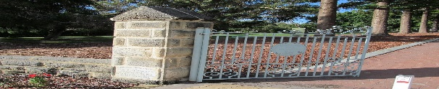  In my street, there are 8 houses with blue gates, 6 houses with red gates and 9 houses with green gates? How many houses altogether have a gate?
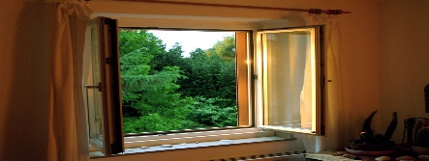  Mr. Brown’s house has 22 windows altogether. 14 windows got broken with a football. How many windows were not broken? | 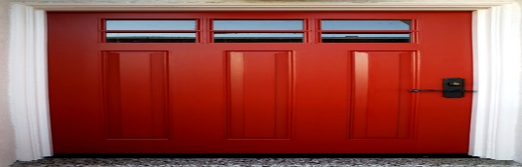  Mr. Black’s house has 22 windows and Mr White’s house has 16 windows. How many more windows does Mr. Black’s house have?
Challenge: Can you make up your own Houses and Homes word problem? Think about the different things that your house has and be as creative as you like.

