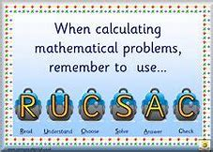
Houses and Homes Word Problems
WALT: read and understand word problems.
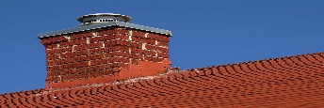  There was smoke coming out of 9 chimneys on one side of the road and smoke coming out of 7 chimneys on the other side of the road.  How many chimneys altogether had smoke coming out of them? | 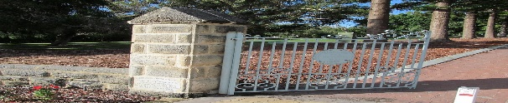  In my street, there are 4 houses with blue gates, 6 houses with red gates and 8 houses with green gates? How many houses altogether have a gate?
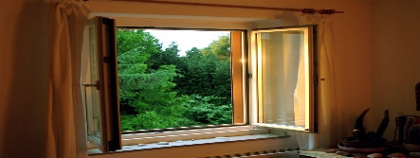  Mr. Brown’s house has 18 windows altogether. 5 windows got broken with a football. How many windows were not broken? | 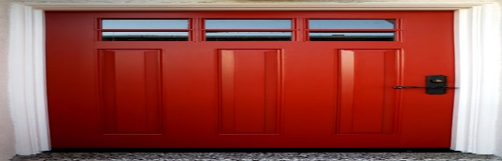  Mr. Black’s house has 19 windows and Mr White’s house has 16 windows. How many more windows does Mr. Black’s house have?
Challenge: Can you make up your own Houses and Homes word problem? Think about the different things that your house has and be as creative as you like.

