Thursday 14th January HC WALT: develop comprehension skills.
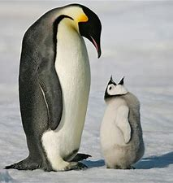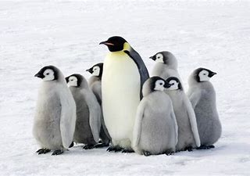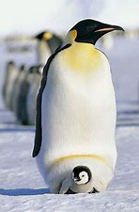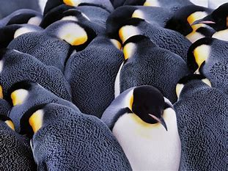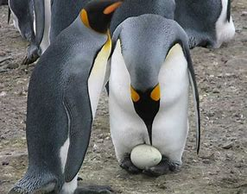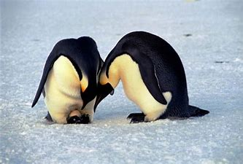
Emperor Penguins
Emperor penguins are the largest of all the penguin species. They eat fish, squid and krill and measure around 115cm tall. Emperor penguins live in Antarctica where temperatures drop as low as minus 60°C. Emperor penguins are protected from icy winds by their body fat and feathers. They also huddle close together in large groups to keep warm. When the female lays her egg, she passes the egg to the male and walks to the ocean. The male keeps the egg safe by balancing the egg on their feet and covering it with a ‘brood pouch’. As the youngsters grow, the parents leave them in groups, called ‘crèches‘, whilst they head to the ocean to fish.
- What do emperor penguins eat?

- Where do emperor penguins live?
___________________________________________________________________
- How are emperor penguins protected from the icy winds?
___________________________________________________________________
- Why do emperor penguins huddle together?
___________________________________________________________________
- What does the female do after she lays her egg?

- How does the male keep the egg safe?
___________________________________________________________________
- Look carefully at the pictures of the emperor penguins above. Can you describe what the penguins look like? Think about their colour, size, beaks etc.
_________________________________________________________________________________________________________________________________________________________________________________________________________

