Thursday 14th January MC WALT: develop comprehension skills.
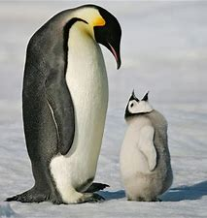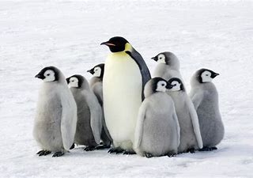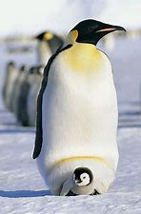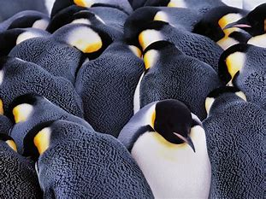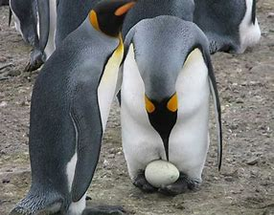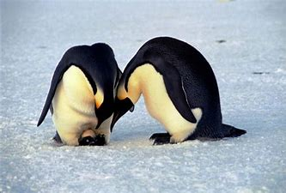
Emperor Penguins
Emperor penguins are the largest of all the penguin species. They eat fish, squid and krill and measure around 115cm tall. Emperor penguins live in Antarctica. Emperor penguins keep warm by huddling close together. When the female lays her egg, she passes the egg to the male. The male keeps the egg safe by balancing the egg on their feet.
- What do emperor penguins eat?

- Where do emperor penguins live?
_________________________________________________________

- How do emperor penguins keep warm?
_________________________________________________________

- How does the male keep the egg safe?
_________________________________________________________

- Look carefully at the pictures of the emperor penguins above. Can you describe what the penguins look like?
__________________________________________________________________________________________________________________

