Thursday 14th January MC WALT: develop comprehension skills.
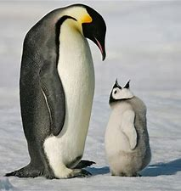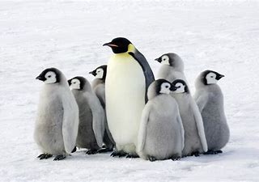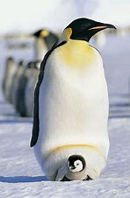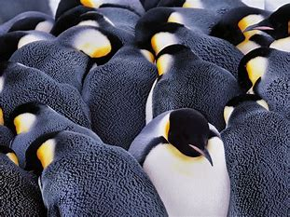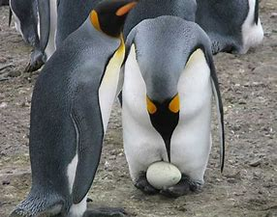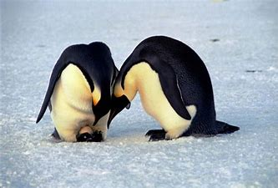
Emperor Penguins

Emperor penguins are the largest of all penguin species.
Emperor penguins are the l_ _ _ _ _ _ of all p _ _ _ _ _ _ species.

They eat fish, squid and krill.
They eat f_ _ _, squid and k _ _ _ _.

Emperor penguins are about 115cm tall.
E_ _ _ _ _ _ penguins are about 115cm t_ _ _.

Emperor penguins live in Antarctica.
Emperor penguins live in A _ _ _ _ _ _ _ _ _.

They keep warm by huddling together.
They keep w_ _ _ by h_ _ _ _ _ _ _ together.

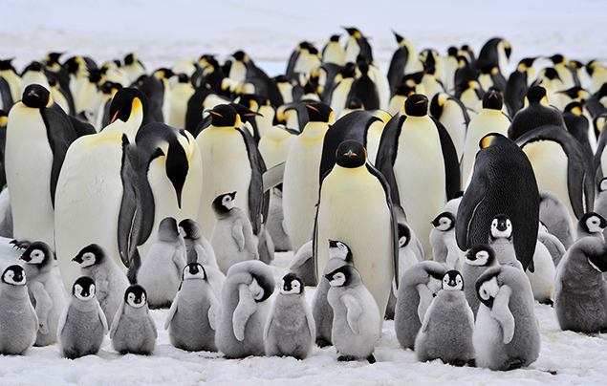
Can you draw a picture of an Emperor Penguin?

