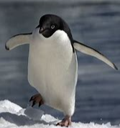  Adelie Penguin | 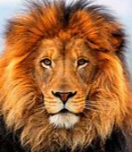  Lion | 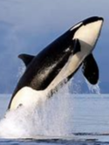  Orca Whale | 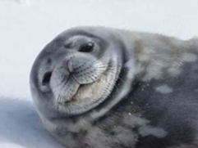  Weddell Seal | 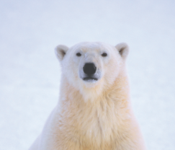  Polar Bear | 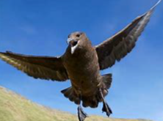  Skua |   Cat | 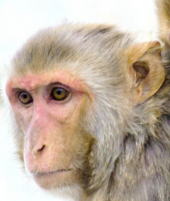  Monkey | 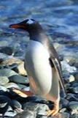  Gentoo Penguin | 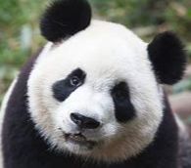  Panda
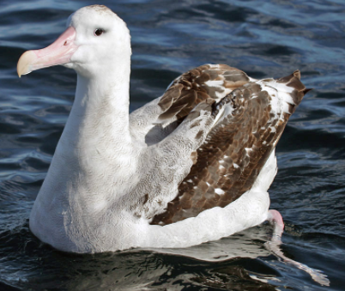  Wandering  Albatross | 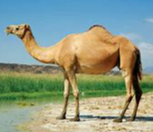  Camel | 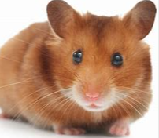  Hamster | 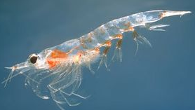  Krill |   Snow Petrel |   Dog | 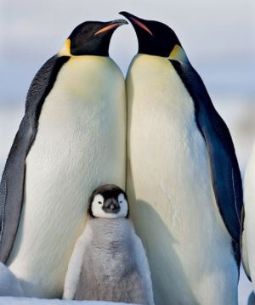  Emperor  Penguin |   Tiger | 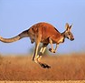  Kangaroo | 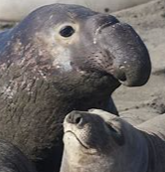  Elephant Seal
Animals of the Antarctic
Some of these animals live in the Antarctic, however, some do not! Can you sort these animals into two sets. Use the Carroll Diagram on the next page to help you sort the animals into two lists.
All you need to complete this task is a pencil and paper – you can do it P3!

