Houses Timeline HC
Look at the timeline below. Can you fill in the missing labels?
Think about what you read in the Houses in the Past Power Point to help you.
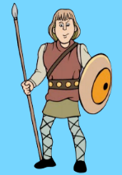 |  |  | 

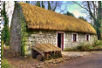 |  |  | 
Tudor Georgian Victorian Medieval
1887 1524 1785

