Houses Timeline
ANSWERS
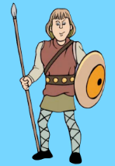 | 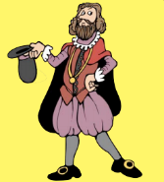 |  | 
 |  |  | 
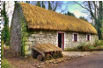 | 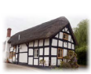 |  | 
Medieval | Tudor | Georgian | Victorian

