Plurals - adding es
WALT: Adding es to make words plural.
We add es to words ending in sh, ch, ss, s, x, z and o to make them plural.

One church Two churches
Read and write the words below again so that they mean more than one (plural). Underline the ending of each word to help you. The first one has been done for you.
  box ____________ |   potato ____________
  witch ____________ |   fox ____________
  kiss ____________ | 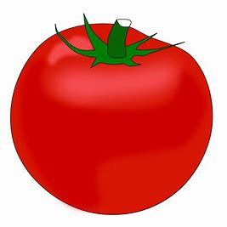  tomato _____________
  brush _____________ | 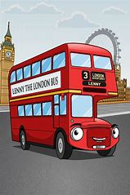  bus _____________
  mess _____________ |   buzz ______________
P3, hopefully you now know and understand the plural rule for adding es.

We add es to words ending in sh, ch, ss, s, x, z and o to make them plural.

Choose 4 of the plurals that you wrote on the previous page and write 4 super duper sentences. Your P3 teachers cannot wait to read them .

- _______________________________________________________

- _______________________________________________________

_______________________________________________________

- _______________________________________________________

_______________________________________________________

- _______________________________________________________

_______________________________________________________

