Plurals - adding es
WALT: Adding es to make words plural.
We add es to words ending in sh, ch, ss, s, x, z and o to make them plural.

One church Two churches
 Read and write the words below again so that they mean more than one (plural).
  box boxes________ |   potato ____________
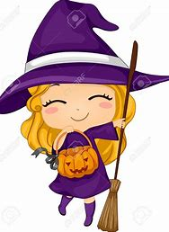  witch ____________ |   fox ____________
  kiss ____________ | 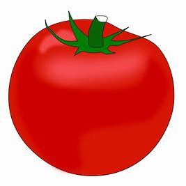  tomato _____________
  brush _____________ | 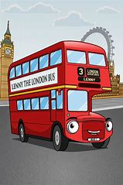  bus _____________
  mess _____________ |   buzz ______________

