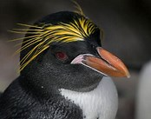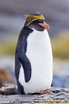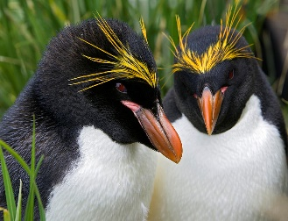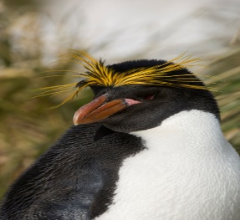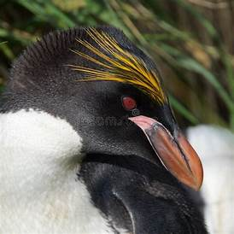
My Macaroni Penguin Factual Report

________________________________________________________________________________________________________________________________________________________________________________________________________________________________________________________________________________________________________________________________________________________________________________________________________________________________________________________________________________________________________________________________________________________________________________________________________________________________________________________________________________

