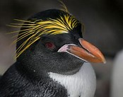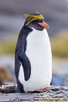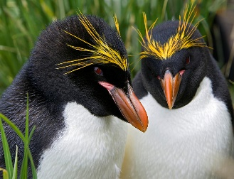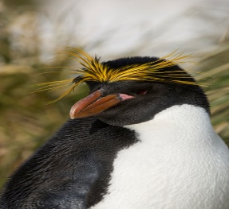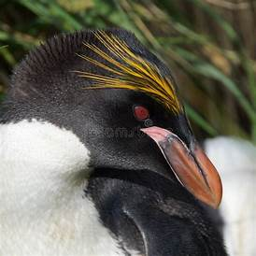
My Macaroni Penguin Factual Report

_________________________________________
_________________________________________
_________________________________________
_________________________________________
_________________________________________
_________________________________________
_________________________________________
_________________________________________
_________________________________________
_________________________________________

