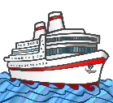
My Antarctica Ship HC
Draw and label a picture of your ship.

