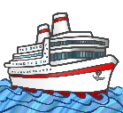
My Antarctica Ship HC
Write a description of your ship. Don’t forget to include the name of your ship, the materials it is built from, the size and speed of your ship, the size of the crew and any equipment it carries.
_______________________________________________________________________
_______________________________________________________________________
_______________________________________________________________________
_______________________________________________________________________

