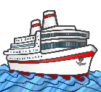
My Antarctica Ship MC
Draw and label a picture of your ship.

