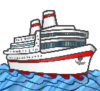
My Antarctica Ship MC
My ship is called ____________________________________________.

It is built from ______________________________________________.

It is _______________meters long and weighs _____________tonnes.

It is powered by ___________________________________.

My ship has a crew of ____________________________ people.

